Chapter-1
Introduction
1.1 Overview

Indian Railways is the principal mode of transport in the country. It is one of the world’s largest rail networks under a single management. The route length is around 63,332 km[10] with more than 8000 stations[10]. As it is the backbone of nation’s transport system, IR owns more than 25,000 wagons[10], 45,000[10] different types of coaches and 8000 locomotives[10]. The system carries about 5,000 million[10] passengers generating a traffic output of 340 billion[10] passenger kms.

So many people travel daily in train and came across so many railway station and platforms. There is always problem to locate a book stall, canteen, bathroom, waiting room etc. on unknown station/platform. So we wanted to build an android app which will inform you which will be the next coming station and what is the layout of stations, like how many platforms, where is police station on map/own display.

1.2 Problem Definition
In railway guide system user can search all information about train, station, route, time required to reaching to destination. Apart from this through our system passenger access information like nearest tourist places, passenger can view the whole platform wise layout of a particular station. passenger can set a reminder of the particular station, which when arrives, the application will send an alert sound or vibrate. Also The passenger will be able to view the amount of time the train is going to wait at the particular station. Passenger can post complaints about the services in the train. The passenger can receive alerts and alarms for protection against thefts to take. The main aim of the project was to develop a application which would facilitate to access information about train, station layout, nearest tourist places etc through an effective and yet simple GUI for a normal passenger intending to travel in railways. Consequently, the higher number of passenger uses the train to travel from source to destination. so we proposed a system railway
1.3 Motivation for the project
The idea behind choosing to develop this application is that, day to day travelling via railways has become a tedious and complicated job which requires a lot of experience and knowledge about the place we visit. Hence to overcome this problem and tiring job of locating places on platforms like washrooms, restrooms, bookstalls etc we decided to provide an application which can provide us the features to make our journey easy and reliable. We wanted to develop a Indian Railway Commute Android App which will help user to locate some place/things quickly on unknown station platform and also give us the halt time of the station with the alert of the arrival of the next station. Instead of standing in line to wait for the booking of the lockers or waiting rooms or taxi services, we provide features to book it before hand while approaching the station sitting in your train.
1.4 Design Idea
The percentage of people trvelling by train is enormous.The inconvenience faced by passengers is to search various places on platform.Our application provides feature of locker booking and notification to passengers about the train arrival and departures time.our android application helps the user to provide the tourist places nearby.
1.5 Achievements
In railway guide system user can search all information about train, station, route, time required to reaching to destination. Apart from this through our system passenger access information like nearest tourist places, passenger can view the whole platform wise layout of a particular station.This application being user friendly helps in posting different messages and also getting notifications about the timing of train.

Chapter 2
- Software Requirement Specification (SRS)
2.1 Introduction
    - Purpose of this document
This document gives the functional and software requirements, and the order valid detailing of this application. This document also explains assumptions and limitations, other aspects of this application.
2.1.2 Scope of the development project
Passenger Module
The passenger can register to use the app creating id, password. The passenger can login to the system with its own id and password created at the time of registration. The passenger will be receiving the notification of arrival of the next station. The passenger can view the whole platform wise layout of a particular station. The passenger can set a reminder of the particular station, which when arrives, the application will send an alert sound or vibrate. The passenger will be able to view the amount of time the train is going to wait at the particular station.
Station Master
The station master can login to his account of his station. The station master can feed in data of his station. The station master can send important notification to the passenger on the station. If baggage is reported lost the immediately notify the station staff and the other station masters, where ever the train is going to stop.

Station layout module
End user can search for next coming station and can see the layout of next station. It check all shops, tea stall, hotel on the coming station, number of platform, on which platform train will arrive etc. Station master add the station layout, information of station.
Notification
The passenger can set a reminder of the particular station, which when arrives, the application will send an alert sound or vibrate. The passenger will be able to view the amount of time the train is going to wait at the particular station. All information of arriving time of train, departure time of train, route add by station master.
Station information:
Displays the time table of the trains i.e arrival and departure time of the train. Cost of tickets according date, the train and the source and destination. Whenever the train has been delayed the passengers will be notified of this delay and the new arrival time.
Complaints:
Passenger can post complaints about the services in the train. The passenger can receive alerts and alarms for protection against thefts to take precaution. If baggage is reported lost then station master immediately notify the station staff and the other station masters, where ever the train is going to stop.
Tours and travel guide:
The passenger can access information about various tourist places at the particular station. Passenger can access all the information of nearest tourist places like how far from station, rickshaw, taxi available or not etc.
Locker
Number of locker, available locker, booked locker all information is add station master. Our user can access all this information and passenger can book a locker.
  - General Description
    - User personas and Characteristics
The user of this product/system will be any citizen who is traveling through train and want information about trains and station.
2.2.2 Product perspective
Indian Railway has so many people commuting via trains. People often find it hectic and time consuming to locate places on unknown station/platform. To save time and effort we want to build an android application which will inform you about the next coming station and what is the layout of stations(location of washroom, waiting rooms, book stalls, police station etc), like how many platforms, where is police station on map/own display. This will help user to get to know the next station before reaching the station and help to locate whatever we need on that station. Will would also like to add one more feature like app would show how much time train will stay on this station and remind the user 30 sec before. The scope does not involve the out of the station information except for the tourist places. Software has two major component one the server and the second one is the mobile application. The server will require Windows XP/Vista 7 machine with minimum 1GB RAM and 100 GB hard disk. The server machine also required WIFI devices sing which it can create Wireless Ad-hoc network.

  - Overview of Functional Requirements
2.3.1 Overview of functions performed
Station master:
    - System should support Android handset
    - System should have internet on mobile
    - System should support to GPS on mobile
    - System should have support to register new user
    - System should have enter in their profile, when they login with their login credentials
    - System should support to add and update profile.
    - System should support to add new information.
    - System should support to add layout of station.
    - System should support to send notification message.
    - System should allow users to create/update their own profile.
    - System should give connectivity to client
    - System should have to maintain database.
    - System should allow multiple users at a time.
    - System should maintain update of user
    - System should maintain update of station master

User:
- System should support Android handset
- System should have internet on mobile
- System should support to GPS on mobile
- System should have support to register new user
- System should have enter in their profile, when they login with their login credentials
- System should able to get the layout of station
- System should able to receive notification message
- System should able to receive proper error message when system is fail to connect to internet.
2.3.2 Deployment:
Deployment would be done on android phone and apache tomcat as the web server.

  - Overview of Non-functional Requirements
2.4.1 Performance Requirements:
- Performance is the main concern as our website should link to all the android phones of the clients at the back-end; store all the data in the database.
- The speed of system processing the data and mapping to the database should be as fast as the movement of the user
- The response time for refreshment and retrieving information must be low.

2.4.2 Safety Requirements:
To safely use of this system, the covering image should be large size seleted by end user, because of that may be loss of source data.

2.4.3 Security Requirements:
For using this system end user can enter username and password to login form in case of wrong information. account will be blocked if attempt is greater than 3 times.
    - Operating Environment
Software has two major component one the server and the second one is the mobile application. The server will required Windows XP/Vista/7 machine with minimum 1GB RAM and 100 GB hard disk. The server machine also required WIFI devices sing which it can create Wireless Ad-hoc network. Mobile application will support Android phones so at least 2 Android devices required getting the output.
    - General Constraints, Assumptions, Dependencies, Guidelines
The user is expected to have Android Mobile phones and should be able to send and receive data when connected to wifi range. First the user has to register to wifi network to use the service. Network gives the functionality to login and registration facility. The registered user uses this network to send and receive messages when connected to wifi network.

  - Specific Requirements
    - External Interface requirements
      - User Interfaces

Station master:
- Registration Page
- Login Page
- Profile Page
- Enter data of its station Page
- Layout of its station Page
- Send notification Page
- Registered compliant Page

User:
- Registration Page
- Login Page
- Searching next station Page
- Station Layout Page
- Searching tourist place near station Page
- Message to user according to search Page
- Message from station master Page
- Compliant registration Page
    - Hardware Interfaces
Mobile application will get installed on mobile devices. These mobile devices should have WIFI device thorough which it will connect to server.
      - Software Interfaces
- Operating System: Windows XP/Windows Vista/Windows 7.
- Database: MySql 6.0.
- Android 2.2 supported mobile handset
- Tomcat 6
- JDK 1.6
- Eclipse 3.4
      - Communication Interfaces
Here we will be using WIFI network and going to create our own communication protocol. Software will also support BASE64 encryption logic while sending data to server. Server will support HTTP protocol for web based access

    - Detailed Description of Functional Requirements
Function: | Authentication
Precondition: | User has valid email-id and password.
Steps: | - Sign up for application  - Enter valid email-id and password.  - Get server access.  - Successful log-in
Post-condition: | - Login Successful.  - User can successfully access the features of the app.
Alternate Flow: | - If email-id and password is invalid check again.  - If the user forgets the password click on the forgot password option.  - If the user forgets user-id then system verifies and provides a new user-id and password.

2>Update Application.
Function: | Uploading database according to the passenger.
Precondtion: | Updating the data.
Steps: | - Server Authentication.  - Check the database.  3>Update the changed data.
Post Condition: | Data Updated.
Alternate Flow: | NA

3>Notification
Function: | Notification
Precondtion: | User should be logged in and GPS should be activated.
Steps: | 1>Login to the app.  2>Check the GPS activation.  3>Server authentication.  4>Check the database for notification.  5>Notify the user with respective notification related to tickets reservation ,destination, timings for next railway stop , etc.
Post Condition: | User Notified
Alternate Flow: | 1>Check the GPS activation ,if not, activate and check again.  2> If GPS not available notification failed.

4> Functional Requirement for Setting Reminder
Functions: | Reminder
Precondition: | Account creation and user should be in the train.
Steps: | - Login.  - Choose the arriving station.  - Set alarm.
Post condition: | Alarm rings on arrival of the station
Alternate Flow: | If the User cannot login, alarm cannot be set hence reminder will not ring.

5> Functional Requirement for Viewing Layout
Function: | View Layout of the particular platform.
Precondition: | Account creation and user to be present on particular platform
Steps: | 1>Login to the app.  2>Select your platform  3>Check the layout according to requirement
Post condition: | Viewing the layout
Alternate Flow: | If user cannot login , then he cannot access layout.

6> Functional Requirement for Booking a locker
Function: | Book locker at a particular station.
Precondition: | Account creation and user to be travelling towards the station
Steps: | 1>Login to the app.  2>Select your platform  3>Check availability of locker  4>if locker available Book locker.
Post condition: | Locker booked
Alternate Flow: | 1>Login to the app.  2>Select your platform  3>Check availability of locker  4>if locker not available locker not booked.

7> Functional Requirement for Booking a Taxi/Rickshaw
Function: | Book Taxi/ Rickshaw at the station your destination
Precondition: | Account creation and user, destination
Steps: | 1>Login to the app.  2>Select your destination  3>Book taxi/rickshaw according to its rates.
Post condition: | Taxi/ Rickshaw booked

7> Functional Requirement for sending Alert
Function: | Alerting the passengers and sending notifications against thefts and danger one.
Precondition: | Station master should register station
Steps: | 1>Login to the app.  2>Broadcast notification to the passengers
Post condition: | Locker booked
Alternate Flow: | If not a user then cannot send alert on the particular station.

8> Functional Requirement for Searching tourist places
Function: | Searches for places of tourist interest in the area of that station
Precondition: | Station master should register station
Steps: | 1>Login to the app.  2>Broadcast notification on platform
Post condition: | Locker booked
Alternate Flow: | If not a user then cannot send alert on the particular station.

9>Functional Requirement for registering a Complaint
Function: | Registers complaints of the passenger against the services of the railway
Precondition: | Passenger should be registered as a user
Steps: | 1>Login to the app.  2>Write Complaint
Post condition: | Locker booked

    - Quality Attributes
- Security:
The security aspect of the system takes into consideration proper authentication when a user is trying to login.
- Availability:
The system is available to the user at any station platform and user can make use of the system at that time.
- Reliability:
The system is reliable and meets the performance requirements for the access by user.
- Maintainability:
The system is modular and hence is flexible enough to allow modification, addition or deletion of layout of platform.The system maintains a database to store the information. Any modification, deletion or addition can be handled using script.

Chapter 3
High Level Design
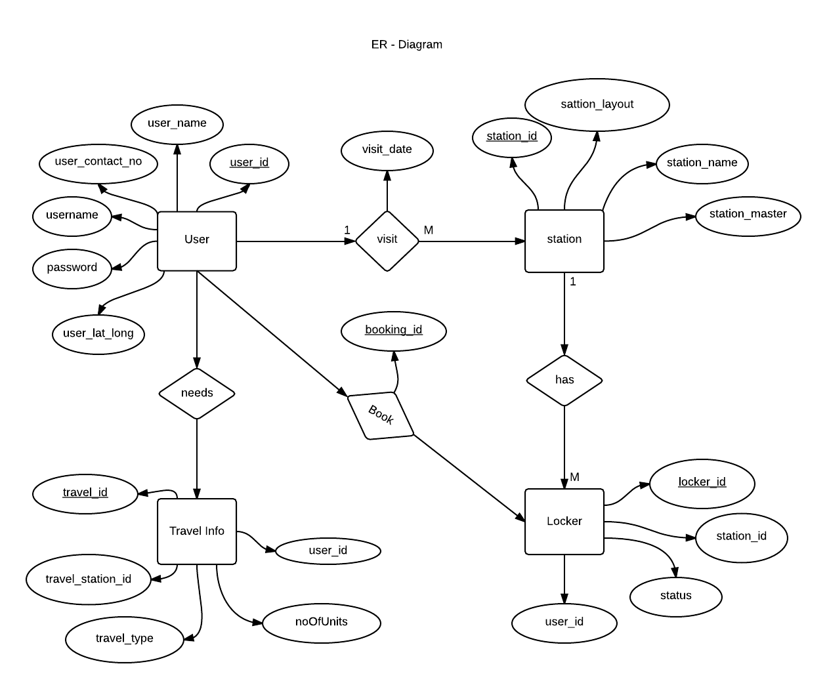
  - Entity Relationship Diagram

DESCRIPTION:
The Entity-Relationship diagram above presents a view of the database used in our Rsil commute system. The database mainly consists of the user information, station and station master information, locker information as well as the train information. This information is updated by the admin in the database. The database consists of variety of linked table that consists of data obtained by the station master about the station. The admin feeds in the other necessary data.

    - Block diagram

USER REGISTRATION
STATION MASTER
PASSENGER
USER INTERFACE
USER INTERFACE
Add Station Layout
Send Important Notification
View and Update Complaints
View Station Layout
View Upcoming Station
View notifications
Set Reminder for Destination Station
Post Complaint
View Tourist information

DESCRIPTION: The above block diagram presents the view of the features that out system consists. Each block has a feature represents by the other blocks as shown above. There are two kinds of registrations station master which is provided by the admin at the server side and the passenger who registers himself on his android application. The station master has the functionality of providing the station layout, send notifications and view and update the complaints of the passenger. The passenger on the other hand receives these notifications and provides the complaints regarding the train or station. Passenger can view station layout of the upcoming station and the tourist information.
  - Database schema
This database schema provides the structure of the databases storing the information required.
- User Database
Database schema and data
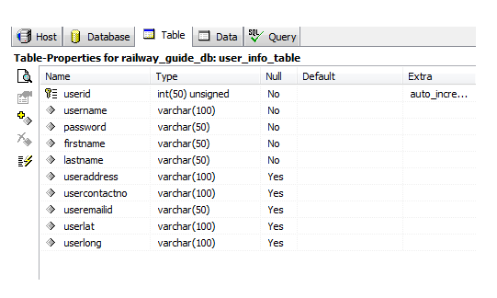

This table stores information about the user that is the passenger who enters these details during registration.

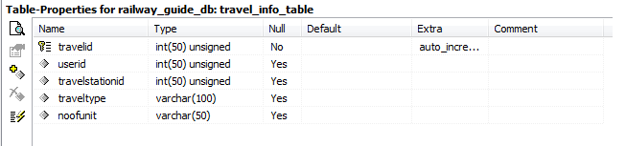
- Station Information Table
Database Schema and data
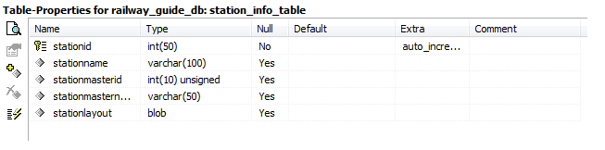
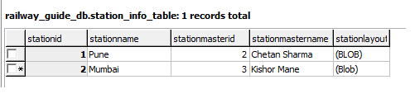

This Table stores the information regarding the station stored by the admin.
- Locker Information Table
Databse Schema and data
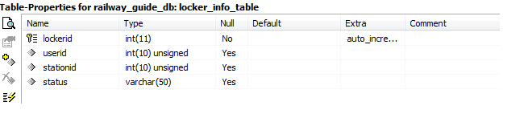
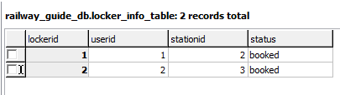

This table stores the record for the lockers booked and available at the particular stations
- Station Layout Information Table
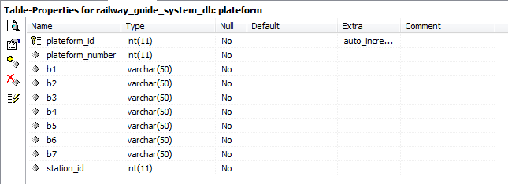
Database schema and data

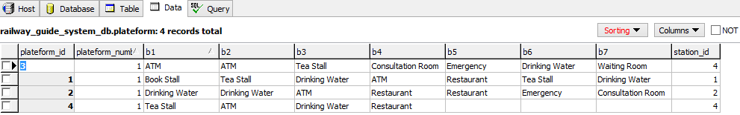

This table is used to store the platform layout set according to the station master of that station.
- Station Master Information table
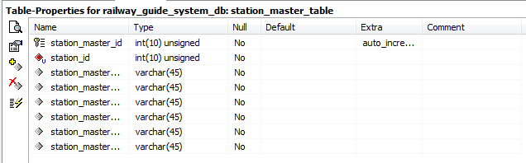
Database Schema and Data

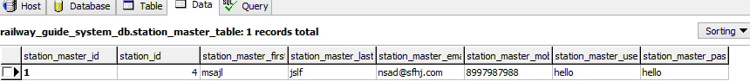
This table stores information about the station master of the stations.
- Train Information table
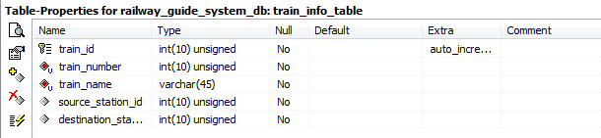
Database Schema and Data

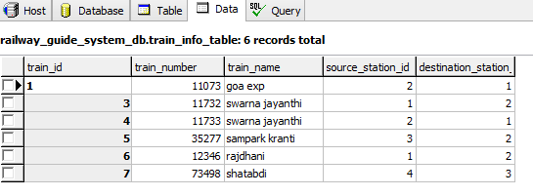

This table consists of the information about the train like the number source station destination station etc.
- Train Route Information table
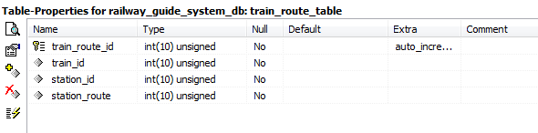
Database and data

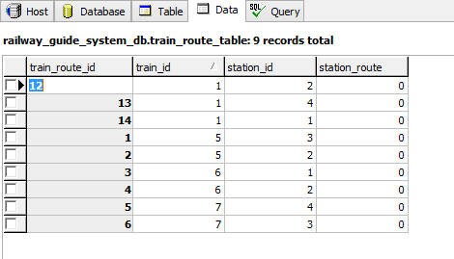

This Table stores the route through which it will pass.it stores all the station ids it will pass through.
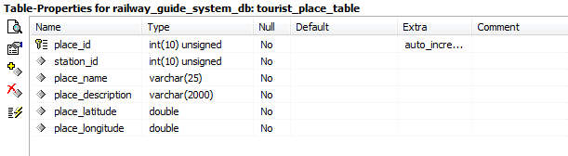
- Tourist Place table
Database Schema and Data

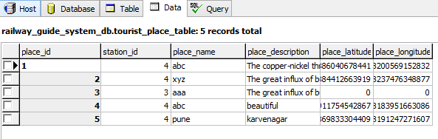

This table stores information about the tourist places of the particular stations.
- Admin Table
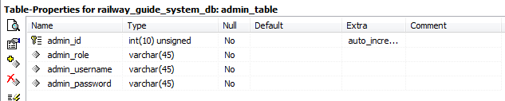
Database Schema and Data

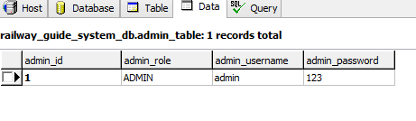

This table stores the login details for the admin.

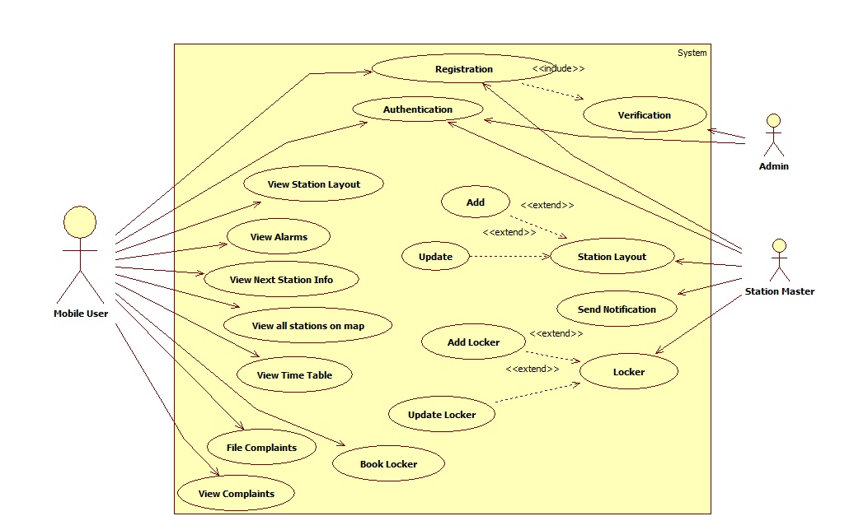
  - UML diagrams
    - Use Case diagram
This is a use case diagram for Rail Commute System. The actors here are the admin, station master and the passenger. The admin has the functionality as shown above of registration verification and authentication. The passenger has been provided with the features of the application which he/she can access using the user interface. Station master has the functionality to provide the station layout notification and update the complaints of the passengers.

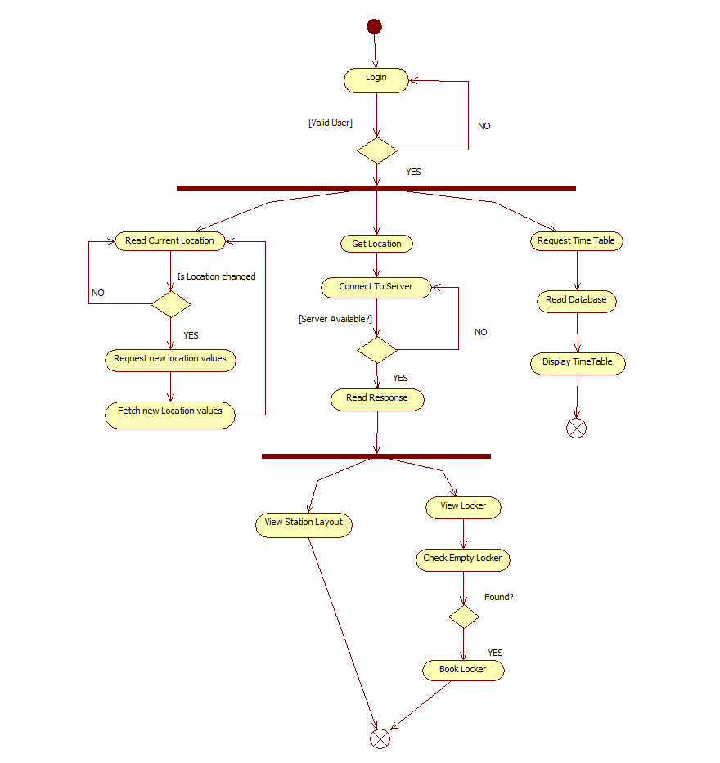
    - Activity diagram
The above id an activity diagram of the railway commute system. Activity in our system starts with a login for user as well as admin and station master. After checkin the authentication of the user , the actors perform various functions. The passenger has to be connected to server at all times to access the data like station layout and to receive notifications. The station master and the admin at the server side add the data necessary for the passenger to view.
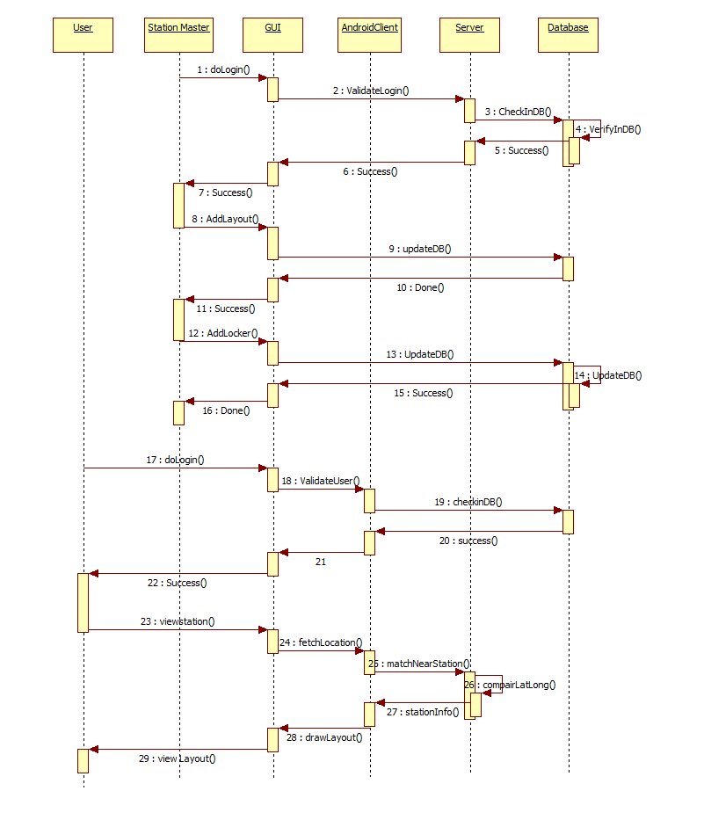
    - Sequence diagram

This diagram presents the sequence of events in the system. The event start with the user login then on success() of that event passenger can view nearest station and access other features. The station master can provide the station layout and perform other functions. The admin stores the station by getting it coordinates through the google map api and on comparison to the passenger’s coordinate, the approaching station is notified to him/her and also adds other required informations.
    - Deployment diagram
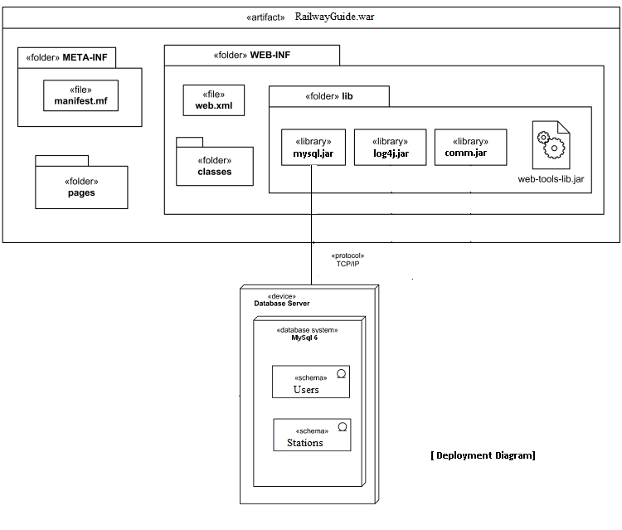

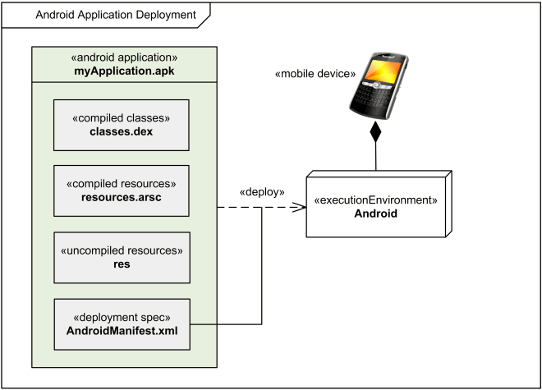

This diagram shows the deployment of our application on the android OS and the tomcat server. It shows the communication of the application with the server side where the admin and station master can access the website and add the required information. The passenger downloads the android APK to access the features of this system.

    - Package diagram
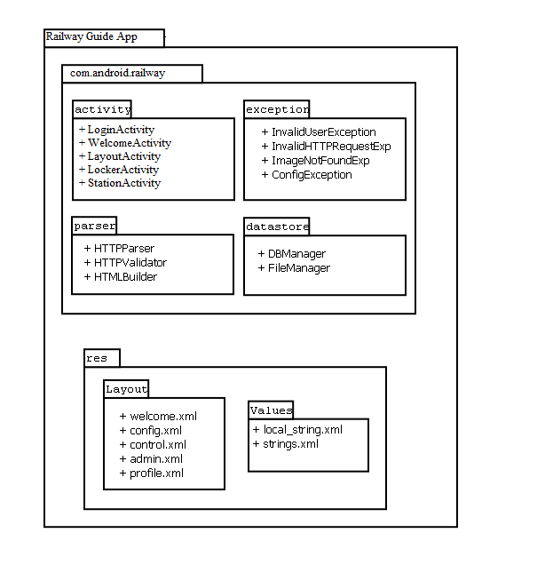
This diagram shows the packages involved in developing this application. The above diagram shows the packages created to store similar type of files together to avoid confusion, reduce time consumption and the code can be viewed easily. The android activity is the client side for the android application. The ‘res’ is the server side for the website to be accessed by the station master and the admin.
    - Component diagram
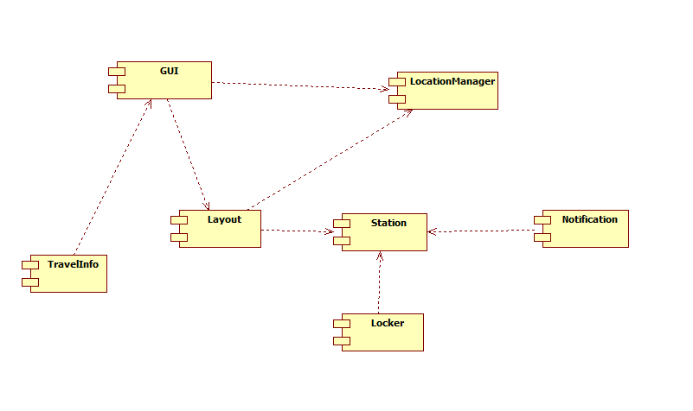
The component diagram shows the components present in the system. GUI is required to access the features of the system by the user. Each Station has a layout, the number of lockers to be booked and the notifications to be sent by its station master.

3.4.7 Class Diagram
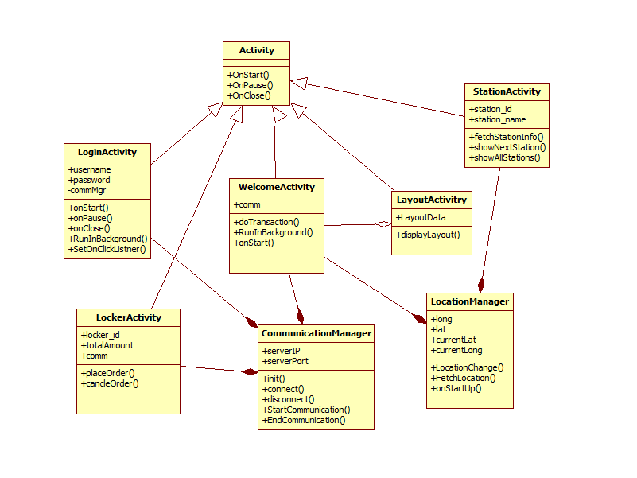
The class diagram shows the classes used in this system. The activity is the main class consisting of all the other activities which inherit its properties. The relationship with the communication and location manager with the particular activities is shown as above.

Chapter 4
Technology
4.1 JSP(Iava server pages)

What is JavaServer Pages?
JavaServer Pages (JSP) is a technology for developing web pages that support dynamic content which helps developers insert java code in HTML pages by making use of special JSP tags, most of which start with <% and end with %>.

The following JSP pages are used in our projects:
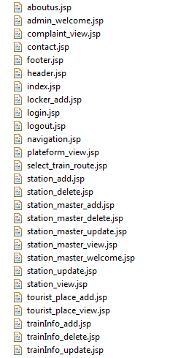

Setting up Web Server: Tomcat
A number of Web Servers that support JavaServer Pages and Servlets development are available in the market. Some web servers are freely downloadable and Tomcat is one of them.
Apache Tomcat is an open source software implementation of the JavaServer Pages and Servlet technologies and can act as a standalone server for testing JSP and Servlets and can be integrated with the Apache Web Server.

4.3Servlet

What are Servlets?
Java Servlets are programs that run on a Web or Application server and act as a middle layer between a request coming from a Web browser or other HTTP client and databases or applications on the HTTP server.
Using Servlets, you can collect input from users through web page forms, present records from a database or another source, and create web pages dynamically.

Description:
Package name: com.java.railway.servlet
In this package all servlet class is there. Our class extends with httpservlet class.
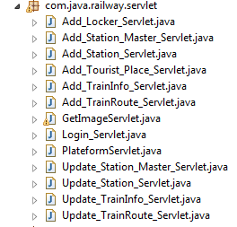
Login Servlet.java
This class is used to verify the admin
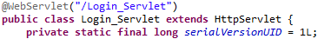
Package name: com.java.railway.dbwrapper
In this package all class is related to database operation. Means various class is used to add, update, view delete station info, train info etc
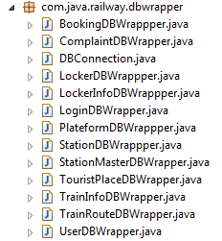
4.4 Mysql database

MySQL Database:
MySQL is a fast, easy-to-use RDBMS being used for many small and big businesses. MySQL is developed, marketed, and supported by MySQL AB, which is a Swedish company. MySQL is becoming so popular because of many good reasons:
4.5 Android
Android is a recently developed operating system designed for mobile devices. It was developed by Google and uses a Linux based kernel, Java compatible libraries along with the just-in-time compiler for development in the Java programming language. It supports many hardware components. Common hardware consists of cameras, a WiFi communications chip, cellular commutations chip, Bluetooth sender and receiver, and a color touch screen. The Android Application Program Interface (API) contains many functions and classes to control the cellular devices. This functionality is all available in a single device with at least a day worth battery life. For this project H.263 was used in development on the Android device. Android is a software stack for mobile devices that includes an operating system, middleware and key applications. The Android SDK provides the tools and APIs necessary to begin developing applications on the Android platform using the Java programming language.

Features
- Application framework enabling reuse and replacement of components
- Dalvik virtual machine optimized for mobile devices
- Integrated browser based on the open source WebKit engine
- Optimized graphics powered by a custom 2D graphics library; 3D graphics based on the OpenGL ES 1.0 specification (hardware acceleration optional)
- SQLite for structured data storage
- Media support for common audio, video, and still image formats (MPEG4, H.264, MP3, AAC, AMR, JPG, PNG, GIF)
- GSM Telephony (hardware dependent)
- Bluetooth, EDGE, 3G, and WiFi (hardware dependent)
- Camera, GPS, compass, and accelerometer (hardware dependent)
- Rich development environment including a device emulator, tools for debugging, memory and performance profiling, and a plugin for the Eclipse IDE
4.6 SQLite:

What is SQLite?
SQLite is an in-process library that implements a self-contained, serverless, zero-configuration, transactional SQL database engine. It is the one database, which is zero-configured, that means like other database you do not need to configure it in your system.
SQLite engine is not a standalone process like other databases, you can link it statically or dynamically as per your requirement with your application. The SQLite accesses its storage files directly.
4.7 Google Map Integration:

Google provides this facility using Google play services library which you have to download externally. After downloading, you have to integrate it with your project.In the end one have to integrate your application with Google via Google console

GOOGLE MAP - ACTIVITY FILE
Google provides GoogleMap and MapFragmentapi to integrate map in your android application.

GOOGLE MAP - LAYOUT FILE
Now you have to add the map fragment into xml layout file.

GOOGLE MAP - ANDROIDMANIFEST FILE
The next thing you need to do is to add some permissions along with the Google Map API key in the AndroidManifest.XML file.

Customizing Google Map:

You can easily customize google map from its default view , and change it according to your demand.

ADDING MARKER
You can place a maker with some text over it displaying your location on the map. It can be done by viaaddMarker() method.

CHANING MAP TYPE
You can also change the type of the MAP. There are four different types of map and each give different view of the map. These types are Normal,Hybrid,Satellite and terrain.

ENABLE/DISABLE ZOOM
You can also enable or disable the zoom gestures in the map by calling thesetZoomControlsEnabled(boolean) method.
Obtaining the API key
This part is furthur divided into two steps. First you have to get an SHA1 fingerprint key from your pc and then you have to get map API key from google console.

GETTING CERTIFICATE FROM KEYTOOL
You need to get a certificate key because you have to provide it to google console in order to get your API key for map.Open your command prompt and move to the path where your java jre has been placed.
Replace the percentage part of the command with the path which you will copy from by selecting the window tab and selecting the preferences tab and then selectng the build option under android from left side.
Copy the default debug keystore path and replace it in the cmmand and hit enter. The following result would appear.
Copy the SHA1 key because you need it in the next step.

GETTING KEY FROM GOOGLE CONSOLE
Open Google Console and sign in by clicking a new project.
Click on services from the left tab and then navigate to the Google Maps Android API v2. You have to turn them on like this.Now again go to the left tab and select API access. And click on create new android key. Now paste the key that you copied and put a semicolon and paste your project name and click create. It would be like this.Now copy the API key that has been given to your by android , because you have to paste it into your manifest file.

Chapter 5
Implementation and Coding
5.1 MODULES
5.1.1 Passenger Module
The passenger can register to use the app creating id, password. The passenger can login to the system with its own id and password created at the time of registration. The passenger will be receiving the notification of arrival of the next station. The passenger can view the whole platform wise layout of a particular station. The passenger can set a reminder of the particular station, which when arrives, the application will send an alert to the passenger. The passenger will be able to view the amount of time the train is going to wait at the particular station. The passenger will be provided with nearest tourist places of its respective destination.
5.1.2 Station Master Module
The station master can login to his account of his station. The station master can feed in data of his station. The station master can send important notification to the passenger on the station.
5.1.3 Station layout module
End user can search for next coming station and can see the layout of next station. It check all shops, tea stall, hotel on the coming station, number of platform, on which platform train will arrive etc. Station master add the station layout, information of station.
5.1.4 Notification Module
The passenger can set a reminder of the particular station, which when arrives, the application will send an alert. The passenger will be able to view the amount of time the train is going to wait at the particular station. All information related to the halt time of the train, train route from source to destination station is provided by the application. The passenger can receive alerts and alarms for protection against thefts to take precaution.

5.1.5 Station information Module
Whenever the train has been delayed the passengers will be notified of this delay and the new arrival time.
5.1.6 Complaints Module
Passenger can post complaints about the services in the train..
5.1.7 Locker Module
Number of locker, available locker, booked locker all information is added by the station master. Our user can access all this information and passenger can book the locker available.
5.2 Flow Diagram:
Registrationn and login
Give Train no as input
Fetch Current location
Any Upcoming Station?
Show Station layout
View Notifications
Booking clock-room / view nearby places

  - Implementation Details
    - ServerSide
- JSP Pages in our project:
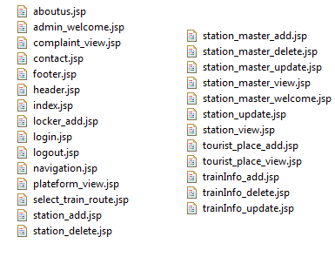
- How database works in our project?
1 database in our project
Database name: railway_guide_system_db
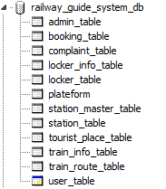

First connect database through connect method in our project
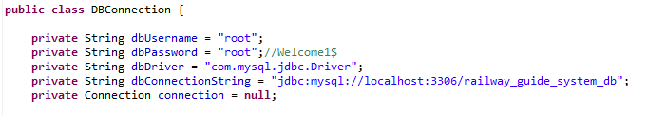

Table schema for railway_guide_system_db database
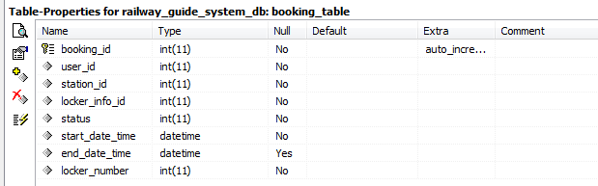
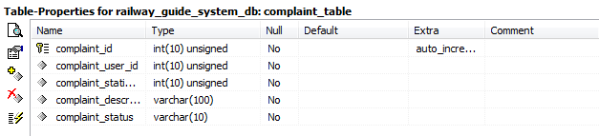
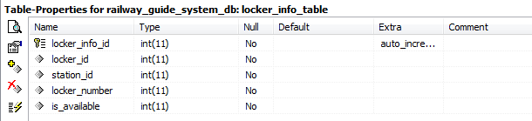
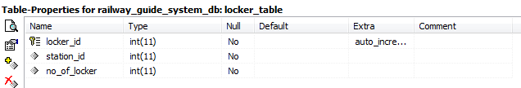
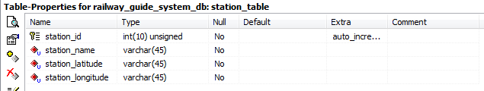
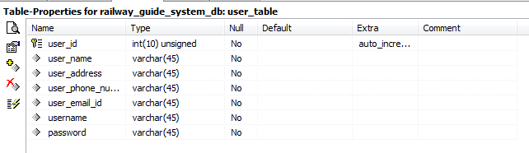

- Class wise description
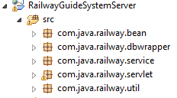

- Description:
Package name: com.java.railway.servlet
In this package all servlet class is there. Our class extends with httpservlet class.
Login Servlet.java
This class is used to verify the admin
Package name: com.java.railway.dbwrapper
In this package all class is related to database operation. Means various class is used to add, update, view delete station info, train info etc

DBConnection.java
This is generic class and is used to make connection with Mysql database.
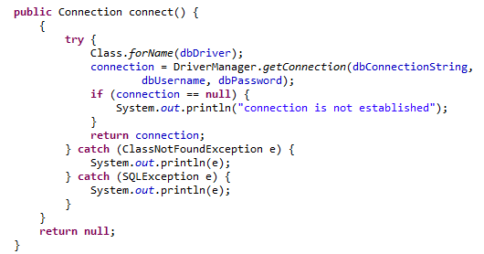

Package name:com.java.railway.bean
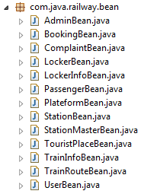
Admin_Bean.java
This class is the place holder class and contains only getter setter methods to access values
BookingBean.java
This class is the place holder class and contains only getter setter methods to access values

Webservice.java
This class is responsible for client server Communication. When client sent request to server then it connect from this class
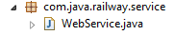

    - Client Side
- Class wise Description Client Side
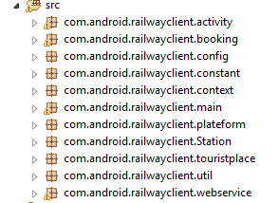
- Layout
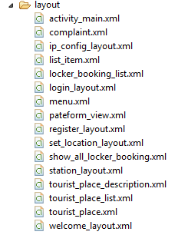
In layout all user interface pages are given

- Description:
Among the many activity which is the first one is given in manifest file.

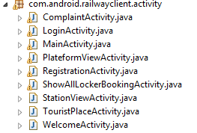
- WelcomeActivty.java:
This class is first time called. In this layout we gave one buttons for start. And option for entering ip address.

- LoginActivity.java
In this class we validate the user from server side. First we took data from login page then we use Login Task to communicate with server.
  - Code Snippet
5.4.1 MAP ACTIVITY
@Override
protected void onCreate(Bundle savedInstanceState) {
super.onCreate(savedInstanceState);
setContentView(R.layout.activity_map);
stationBeanList = ((ApplicationContext) this.getApplicationContext()).getStationBeanList();
try {
MapsInitializer.initialize(this);
} catch (GooglePlayServicesNotAvailableException e) {
// TODO Auto-generated catch block
e.printStackTrace();
}
seekerMapFragment = (MapFragment) getFragmentManager()
.findFragmentById(R.id.mapView);
seekerMap = seekerMapFragment.getMap();
LatLng latlong = new LatLng(18.4, 73.8);
CameraPosition cameraPosition = new CameraPosition.Builder().target(latlong).zoom(6).build();
seekerMap.animateCamera(CameraUpdateFactory.newCameraPosition(cameraPosition));

5.4.2WebServiceParser

public ArrayList<AnnouncementBean> getAnnouncementInfo(Map<String, String> params) {
String response = wSCommunictor.invokeMethod("getAnnouncementInfo",params);
ArrayList<AnnouncementBean> announcementBeanList = new ArrayList<AnnouncementBean>();
try {
if (response != null) {
System.out.println(response);
Log.d("getAnnouncementInfo_webServiceParser", response);
JSONArray jsonArray = new JSONArray(response);
for (int i = 0; i < jsonArray.length(); i++) {
AnnouncementBean announcementBean = null;
JSONObject jsonObject = new JSONObject(jsonArray.getString(i));
if (jsonObject != null) {
announcementBean = new AnnouncementBean(); announcementBean.setAnnouncementId(jsonObject.getInt("AnnouncementId"));
announcementBean.setTrainId(jsonObject.getInt("TrainId"));
announcementBean.setStationId(jsonObject.getInt("StationId"));
announcementBean.setAnnouncementName(jsonObject.getString("AnnouncementName"));
announcementBean.setAnnouncementDescription(jsonObject.getString("AnnouncementDescription")); announcementBean.setAnnouncementDate(jsonObject.getString("AnnouncementDate")); announcementBeanList.add(announcementBean);
}
}
}
} catch (Exception e) {
e.printStackTrace();

5.4.3 DBConnection

public Connection connect() {
{
try {
Class.forName(dbDriver);
connection = DriverManager.getConnection(dbConnectionString,
dbUsername, dbPassword);
if (connection == null) {
System.out.println("connection is not established");
}
return connection;
} catch (ClassNotFoundException e) {
System.out.println(e);
} catch (SQLException e) {
System.out.println(e);
}
}
return null;
}

5.4.4 UserBean

public int getUserId() {
return userId;
}
public void setUserId(int userId) {
this.userId = userId;
}
public String getUserName() {
return userName;
}
public void setUserName(String userName) {
this.userName = userName;
}
public String getUserAddress() {
return userAddress;
}
public void setUserAddress(String userAddress) {
this.userAddress = userAddress;
}
public String getUserPhoneNumber() {
return userPhoneNumber;
}
public void setUserPhoneNumber(String userPhoneNumber) {
this.userPhoneNumber = userPhoneNumber;
}
public String getUserMailId() {
return userMailId;
}
public void setUserMailId(String userMailId) {
this.userMailId = userMailId;
}
public String getUsername() {
return username;
}
public void setUsername(String username) {
this.username = username;
}
public String getPassword() {
return password;
}
public void setPassword(String password) {
this.password = password;
}

  - Screenshots
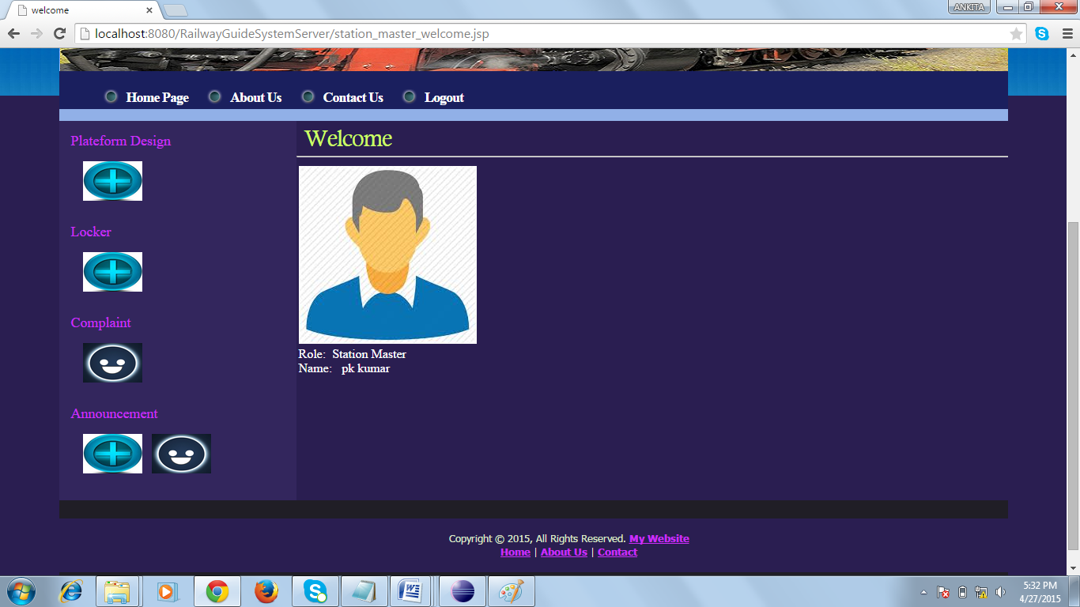
Server side
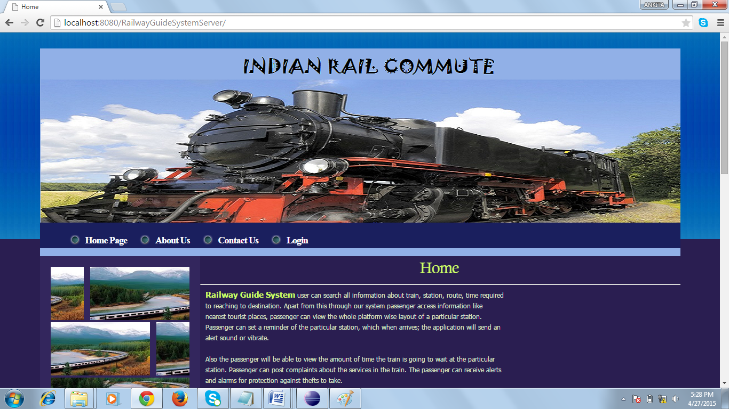

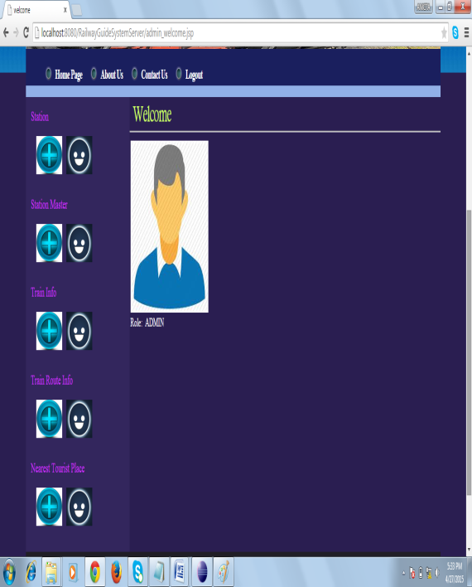

Client Side

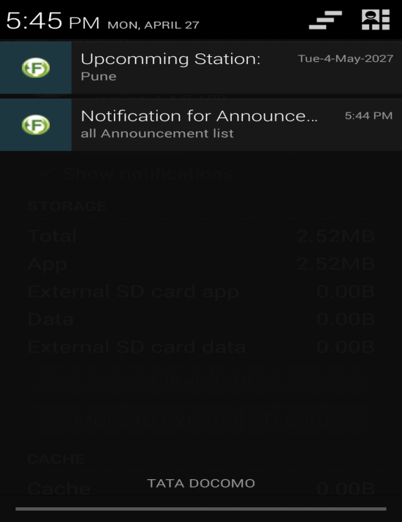
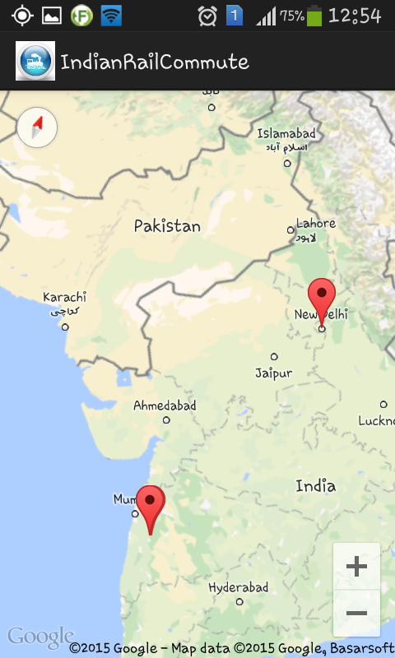

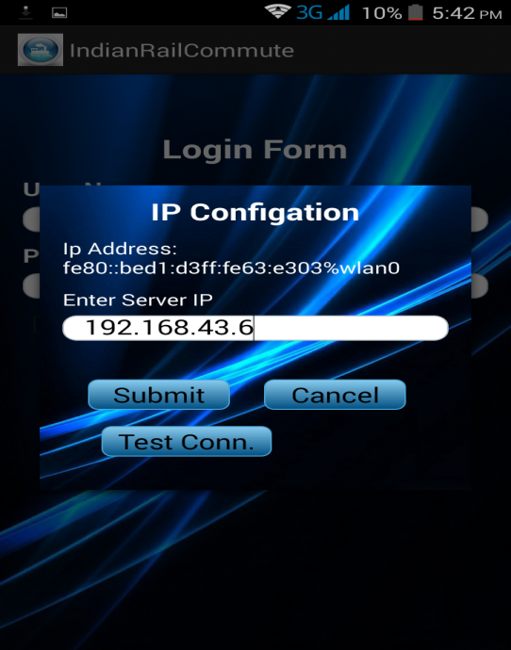
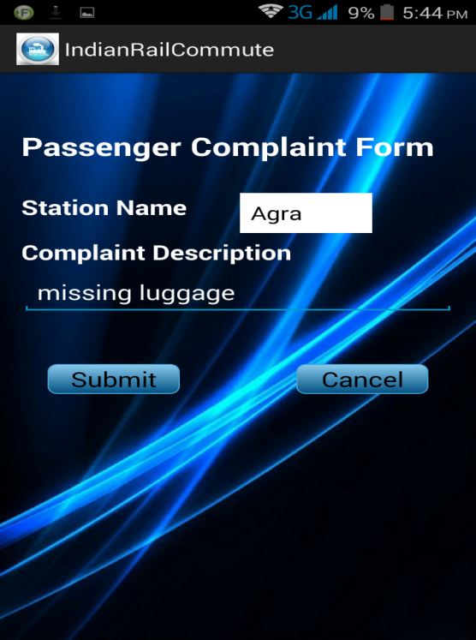

Chapter 6:
Software Testing
TEST CASES:
Unit test:
Test Case ID | 1
Test Case Description | Application should provide login to admin only
Steps | 1. Install and Run the application  2. Login with admin
Test Case Result | Click on login insert valid username and password of admin, Then successfully login to next page
Action Result | Click on login insert valid username and password of admin, Then successfully login to next page
Status | Pass

Test Case ID | 2
Test Case Description | Check functionality for different link
Steps | 1. Run the application  2.Login as admin
Test Case Result | Click on the link, then according to link next page is opened
Action Result | Click on the link, then according to link next page is opened
Status | Pass

Test Case ID | 3
Test Case Description | Admin can insert new station
Steps | 1. Run the application  2.Login as admin  3.Click on add option
Test Case Result | Click on stations option add link, then admin add new station
Action Result | Click on stations option add link, then admin add new station
Status | Pass

Test Case ID | 4
Test Case Description | Admin can add/delete new Station Master.
Steps | 1. Run the application  2.Login as admin  3.Click on add/delete option
Test Case Result | Click on Station Master’s option add link, then admin add new Station Master
Action Result | Click on Station Master’s option add link, then admin add new Station Master
Status | Pass

Test Case ID | 5
Test Case Description | Admin can add/delete Train Info
Steps | 1. Run the application  2.Login as admin  3.Click on add/delete option
Test Case Result | Click on Train Info’s option add link, then admin add Train Info
Action Result | Same as expected
Status | Pass

Test Case ID | 6
Test Case Description | Admin can add /delete train root
Steps | 1. Run the application  2.Login as admin  3.Click on add/delete option
Test Case Result | Click on train root’s option add link, then admin add new train root
Action Result | Click on train root’s option add link, then admin add new train root
Status | Pass
Test Case ID | 7
Test Case Description | Admin can add/delete nearest tourist place.
Steps | 1. Run the application  2.Login as admin  3.Click on add option
Test Case Result | Click on nearest tourist place’s option add link, then admin add new nearest tourist place
Action Result | Click on nearest tourist place’s option add link, then admin add nearest tourist place
Status | Pass

Test Case ID | 11
Test Case Description | Admin can update station information
Steps | 1. Run the application  2.Login as admin  3.Click on update option
Test Case Result | Click on stations option update link, then admin can update station information
Action Result | Click on stations option update link, then admin can update station information
Status | Pass

Test Case ID | 12
Test Case Description | Admin can update registered Station Master information
Steps | 1. Run the application  2.Login as admin  3.Click on update option
Test Case Result | Click on Station Master option update link, then admin update Station Master information
Action Result | Click on Station Master option update link, then admin update Station Master information
Status | Pass

Test Case ID | 13
Test Case Description | Admin can update Train Info information
Steps | 1. Run the application  2.Login as admin  3.Click on update option
Test Case Result | Click on Train Info option update link, then admin update Train Info information
Action Result | Click on Train Info option update link, then admin update Train Info information
Status | Pass

Test Case ID | 14
Test Case Description | Apk should get installed properly.
Steps | 1.Install the application.  2.Open the application.
Test Case Result | Application should be successful installed.
Action Result | Application successfully started.
Status | Pass
Test Case ID | 15
Test Case Description | System should provide the menu from which user can select the option for enter ip address.
Steps | 1.Click on the menu button.  2. Option menu should get open .
Test Case Result | After clicking on the menu system should perform the respective operation.
Action Result | After clicking on the menu system should perform the respective operation.
Status | Pass

Test Case ID | 16
Test Case Description | System should go to login page after click on button start, After filling Ip address.
Test Case Results | After click on start button application shows next page i.e login page.
Action Result | Same as expected
Status | Pass

zTest Case ID | 17
Test Case Description | System should provide the login to the validate users only
Steps | 1. Install the application.  2. First click on the menu  3. Search the application  4. Run application as android application.  5. Go to login page.
Test Case Result | System should provide the username password fields.
Action Result | Insert valid username and password, and submit. System logged in successfully
Status | Pass

Test Case ID |  | 18
Test Case Description |  | System should provide different buttons for searching train, nearest tourist place, lockers etc
Steps |  | 1. Install the application.  2. First click on the menu  3. Search the application  4. Run application as android application.  5. Go to login page.
Test Case Result |  | After login as validate user, next page is opened with various button options
Action Result |  | After login as admin, next page is opened with various button options
Status |  | Pass
Test Case ID | 19
Test Case Description | System should not put the phone  On flight mode while running.
Steps | 1.Run application as android application.  2.Click on start button.
Test Case Result | Application should run and phone should be in on mode.
Action Result | Running properly.
Status | Pass

Performance Testing

Test Case ID | 20
Test Case Description | Phone should not get hang due to application.
Steps | 1.Run application as android application.  2.Click on start button.
Test Case Result | Application should run.
Action Result | Application running and phone working properly.
Status | Pass

Test Case ID | 21
Test Case Description | System should not disturb telephony activity.
Steps | 1.Run application as android application.  2.Click on start button.  3.User can receive incoming calls.
Test Case Result | Application should not block incoming calls.
Action Result | User can receive calls.
Status | Pass
Test Case ID | 22
Test Case Description | System should not block incoming massages.
Steps | 1.Run application as android application.  2.Click on start button.  3.User can receive incoming massages.
Test Case Result | Application should not block incoming massages.
Action Result | User can receive massages.
Status | Pass

Test Case ID | 23
Test Case Description | Application should not run as background service.
Steps | 1.Run application as android application.  2.Click on start button.
Test Case Result | Application should not run as background service.
Action Result | Application is not running as background service.
Status | Pass

Test Case ID | 24
Test Case Description | Application should use minimum battery.
Steps | 1.Run application as android application.  2.Click on start button.
Test Case Result | Application should use minimum battery.
Action Result | Application battery usage is minimum.
Status | Pass

Appendix A : FEASIBILITY ANALYSES
Rail Commute Application: Given a failure case viz. Q, invalid location fetch by users mobile phone, we devise an algorithm for this problem as follows:
For a Problem P1 to be NP-Hard, Satisfiability problem (SAT) must be reducible to P1;
SAT ≤ P ;
Let the propositional formula be: G = X1^X2
Where
X1: True if Latitude/Longitude are invalid
X2: True if destination station name is invalid.

Algo sati()
{
For i: 1 to 2
x_{i} = Choice(True,False);
if G(x₁,x₂) then
Success();
else
failure();
}
Therefore, since the problem becomes a decision problem, it is NP.

Satisfiability and Reducibility:

3 SAT problem is NP Complete. The system can be reduced to 3SAT problem. A 3SAT problem takes a Boolean formula S that is in CNF in which each clause has exactly three literals. 3SAT is a restricted form of CNF-SAT problem.
x₁₋₋Location manager
x₂ - Station Layout View
x₃ - Locker Mgmt

S = (x₁ ^ x₂ ^ x₃)

Algo sat()
{
For i= 1 to 3
X_{i}=Choice(true, false)
If(S(_{x1,x2,x3})= true)
Success()
Else
Failure()
}
As it is polynomial time. It is NP-Complete.

Appendix D- Project Plan and Work progress
Project planning
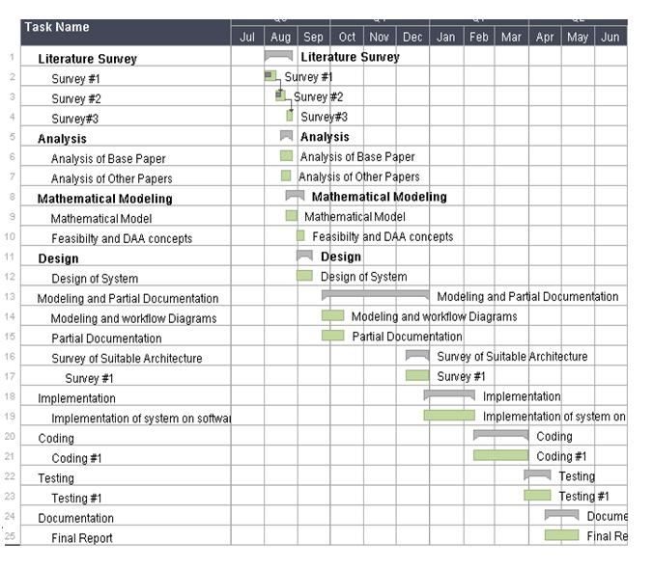
We are planning to implement our system in the following manner. In analysis we will gather all the information related to our project and collect all the related papers. Then we are going to focus on mathematical model and finally we will work on design of the system, coding, testing and documentation

APPENDIX : GLOSSARY
A
API-Application Programming interface specifies how some software components should interact with each other.
B
Base64-Encrytion/Decryption algorithm used while communication between mobile and server. It is used when there is a need to encode binary data that needs to be stored and transferred over media that are designed to deal with textual data. This is to ensure that the data remains intact without modification during transport.
G
GPS-Global Positioning System is a space based satellite navigation system that provides location and time information in all weather conditions,anywhere on or near Earth where there is an unobstructed line of sight to four or more GPS satellite.
H
Haversine- Distance calculation algorithm using latitude longitude
HTTP-Hypertext Transfer Protocol is an application protocol for distributed,collaborative,hypermedia information systems.HTTP is the foundation of data communication for the World Wide Web.
HTTPs-Hypertext Transfer Protocol Secure is a communications protocol for secure communication over a computer network, with especially wide deployment on the Internet.
I
IT-Information Technology is the application of computers and telecommunications equipment to store, retrieve, transmit and manipulate data, often in the context of a business or other enterprise.
J
JSON-JavaScript Object Notation is an open standard format that uses human-readable text to transmit data objects consisting of attribute value pairs. It is used primarily to transmit data between a server and web application as alternative to XML.
O
OOP-Object Oriented Programming is a programming paradigm that represents the concept of “objects” that have data fields and associated procedures known as method. Java, C#,C++ ,Perl, Python and PHP are some examples of object oriented programming languages.
OS –Operating System is software that manages computer hardware resources and provides common services for computer programs.
S
SRS-Software requirement Specification , a requirements specification for a software system , is a description of the behaviour of a system to be developed and may include a set of use cases that describe interactions the users will have with the software.
T
TCP-Transmission Control Protocol is one of the main protocols in TCP/IP networks. Whereas the IP protocol deals only with the packets , TCP enables two hosts to establish a connection and exchange streams of data. TCP guarantees delivery of data and also guarantees that packets will be delivered in the same order in which they arrived.
U
UI-User Interface , in the industrial design field of human-machine interaction ,is the space where interaction between humans and machine occurs. The goal of this interaction is effective operation and control of the machine on the user’s end and feedback from the machine, which aids the operator in making operational decisions.

X
XML-Extensible Mark-up language is a mark-up language that defines a set of rules for encoding documents in a format that is both human-readable and machine readable.

References
[1] IEEE 2013 - Developing an Android based learning application for mobile devices
http://ieeexplore.ieee.org/xpl/login.jsp?tp=&arnumber=6218028&url=http%3A%2F%2Fieeexplore.ieee.org%2Fxpls%2Fabs_all.jsp%3Farnumber%3D6218028
[2] IEEE 2011 - Android: Changing the Mobile Landscape
http://ieeexplore.ieee.org/xpl/login.jsp?tp=&arnumber=5676144&url=http%3A%2F%2Fieeexplore.ieee.org%2Fxpls%2Fabs_all.jsp%3Farnumber%3D5676144
[3] IEEE 2012 - Voice enabled Android application for vehicular complaint system: Using GPS and GSM-SMS technology
http://ieeexplore.ieee.org/xpl/login.jsp?tp=&arnumber=6409133&url=http%3A%2F%2Fieeexplore.ieee.org%2Fxpls%2Fabs_all.jsp%3Farnumber%3D6409133
[4]IEEE 2013 - Hajj crowd management and navigation system: People tracking and location based services via integrated mobile and RFID systems
http://ieeexplore.ieee.org/xpl/login.jsp?tp=&arnumber=6522008&url=http%3A%2F%2Fieeexplore.ieee.org%2Fxpls%2Fabs_all.jsp%3Farnumber%3D6522008
[5] IEEE 2012 - Web based remote exploration and control system using android mobile phone
http://ieeexplore.ieee.org/xpl/articleDetails.jsp?arnumber=6317481
[6]Raman, K.S. and Wig, S., ASCI Journal of Management, 2010, vol 39, page 33-54.
[7] Agarwal S., Singhal R., Mittal R., Freight Operations Information System (FOIS) – advanced architecture & its Future. IJLRST 2013, Vol 2 Issue 2.
[8] Agarwal, V.K., Indian Railways in Full steam, www.pib.nic.in
[9] IEEE 2012 - Android city tour guide system based on Web service
http://ieeexplore.ieee.org/xpl/articleDetails.jsp?arnumber=6201621
[10] http://borjournals.com/Research_papers/Jun_2013/1356IT.pdf

